Sean McHugh
December 12, 2025
Data Analytics Term Project
Exploring Student Stress
Section 1: Abstract and Introduction
In recent years, there has been an increase in stress levels among all students. I was relieved when I first saw this report, as it only confirmed that I was not the only one who had felt the presence of more stress. The question we have to ask ourselves now, though, is why? Why are students feeling an increased sense of stress? Surely the rapid growth of technology has to do something with it, but that can’t be all. Understanding the relationship between different lifestyle factors and well-being is critical for intervention and support of this problem. This project aims to explore how behavioral patterns reflect stress and happiness levels and whether predictive models can reliably identify at-risk students.
Two datasets were used to conduct this study. Dataset 1 identified common student stress factors using likert-scale measures of sleep quality, headaches, academic performance, study load, extracurricular activities, and stress. Dataset 1 attempted to test the hypothesis that a higher study load, more headaches, and poorer sleep correlate with higher stress. Dataset 2 aimed to compare mental health and social media balance. As previously mentioned, technology and social media has rapidly increased so trying to quantify its effect using variables such as screen time, days without social media, exercise, etc. could prove beneficial. Dataset 2 looked to confirm that higher screen time correlates with lower happiness ratings. Using two different datasets with different variables allows for a comparative analysis of academic vs. digital behavior influences. Together, I hope to group students into stress and happiness profiles using unsupervised learning and classify mental health outcomes with reasonable accuracy using supervised learning methods like kNN and regression.
A variety of methods were used throughout the project in an attempt to get a full understanding of not only the data itself but also potential online vs. offline relationships. Distributions, scatterplots, and correlation matrices were put together for exploratory data analysis of both datasets. PCA is used for dimensionality reduction and structural understanding. Student profiles were somewhat successfully put together through k-means clustering. Multiple types of linear regression are used to model stress (Dataset 1) and happiness (Dataset 2). Lastly, kNN classification attempts to identify high vs. low stress groups. All models were evaluated through diagnostic plots, residual analysis, and accuracy curves to see how much we can actually trust the results of each model.

Section 2: Data Description and Preliminary Analysis
Dataset 1 contains variables measured on a 1-5 Likert scale. The dataset covers sleep quality, headaches frequency, academic performance, study load, extracurricular activity level, and stress. Fortunately, there are no major missing data and the variables have good distributional spread. When first looking at dataset 1’s attributes, we notice the histograms in figure 2.1 show mostly balanced responses across Likert values. Variables like stress, study load, and headaches display more variation, potentially making them good predictors. Extracurricular activities and academic performance, on the other hand, are more centralized.

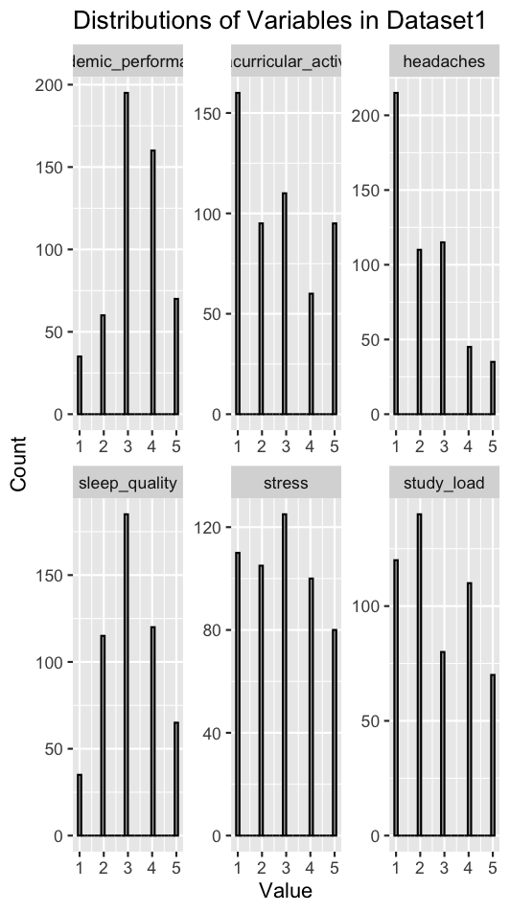
Figure 2.1

Next, scatterplots were put together to compare sleep quality vs. stress and study load vs. stress. These plots were constructed to find some potential initial predictors of stress. Figure 2.2 shows an unexpected slight positive trend, likely due to a data artifactor or nonlinear effect, as it is pretty universally believed that better sleep quality would lead to less stress, not more. Figure 2.3, however, displays a clear positive linear trend between study load and stress. Thus, study load is a perfect initial predictor variable and can be continued to be used across other models.
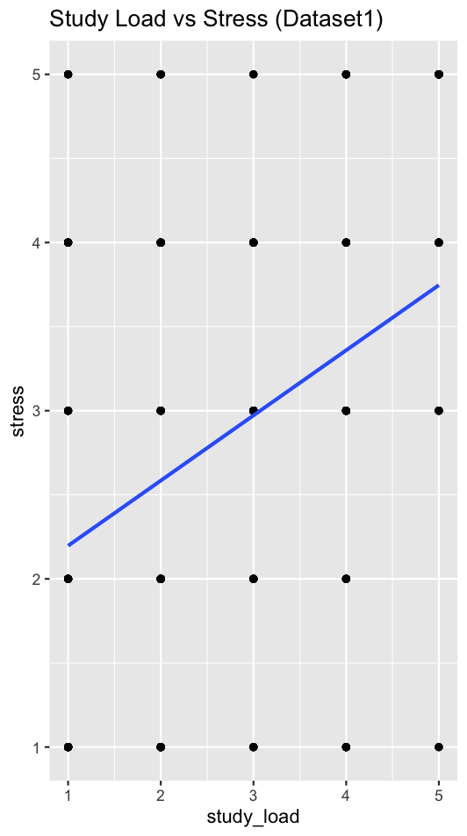
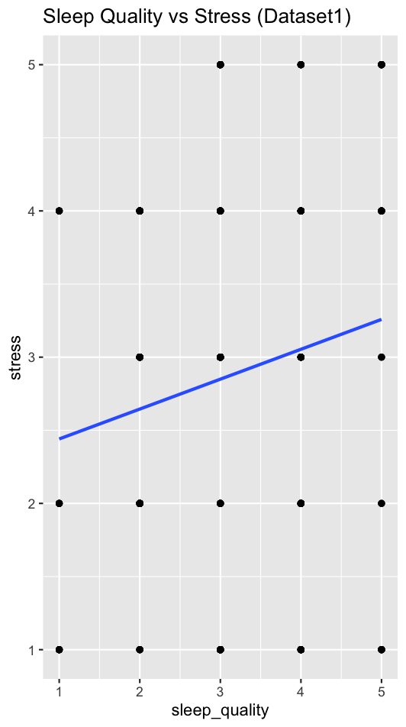
Figure 2.2 (left) and Figure 2.3 (right)

Dataset 2 includes numeric and categorical data among people aged 20-50+. As seen in figure 2.4, all of the variables have plenty of variation, with happiness having the most drastic rightward skew and exercise with the most drastic leftward skew. Outside of those two variables, though, the others show a pretty normal distribution.
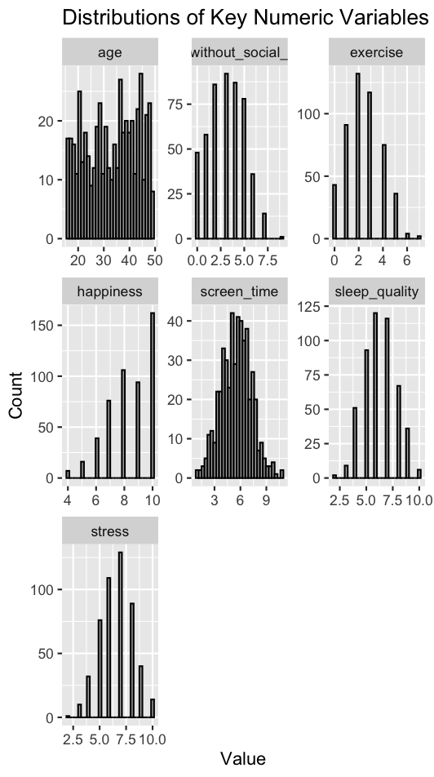
Figure 2.4

Dataset 2’s initial scatterplots display a strong negative relationship between screen time and happiness (Figure 2.5) and a moderate inverse relationship between stress and happiness (Figure 2.6). Expanding on the negative relationship between screen time and happiness will remain a priority throughout the rest of the study.

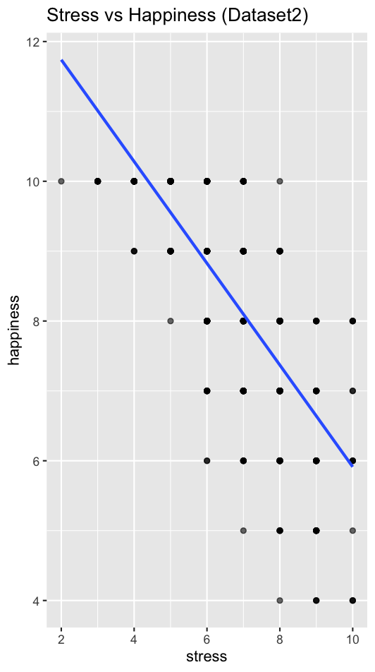
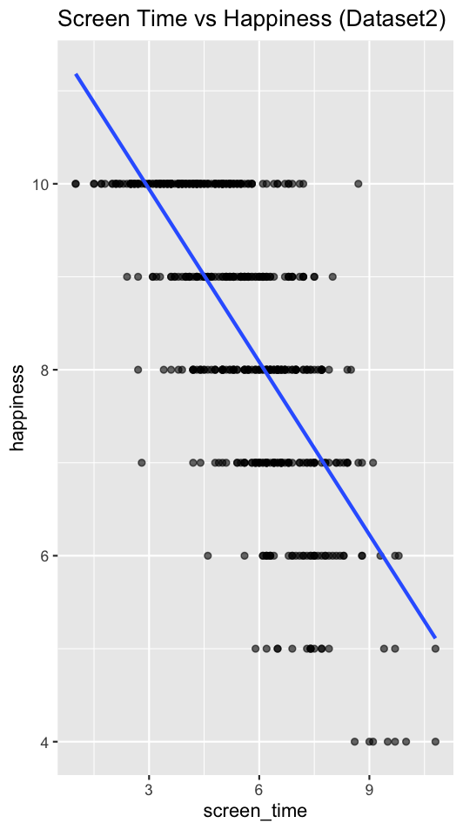
Figure 2.5 (left) and Figure 2.6 (right)

Plenty of valuable insights into both datasets were gained throughout the preliminary analysis, however some potential data limitations remain. Both datasets contained self-reported data, leading to inevitable subjective bias. In other words one person’s definition of a 10 rated happiness could be completely different for somebody else. Next, the likert scale restricts continuous modeling assumptions, as all scales do. Lastly, there is an uneven representation of demographics, limiting any insights we can make into any cross-demographic relationships.
Section 3: Exploratory Analysis
Principal Component Analysis (PCA) and k-means clustering were conducted for dataset 1, while dataset 2 only had k-means clustering. Figure 3.1 displays dataset 1’s PCA biplot where we look further at the variance within the stress factors measured in dataset 1. Principal component 1 (PC1) explains approximately 27% of the variance while principal component 2 (PC2) explains roughly 20%, exemplifying moderate dimensional structure. Further, we can see that study load, headaches, and stress load heavily on PC1 while sleep quality and academic performance load in the opposite direction, suggesting they are negatively correlated with stress factors. Extracurricular activities, on the other hand, have weak loading suggesting it has minimal influence. Altogether, we can interpret PC1 as a general academic pressure and stress dimension while PC2 represents an additional behavior and health dimension.
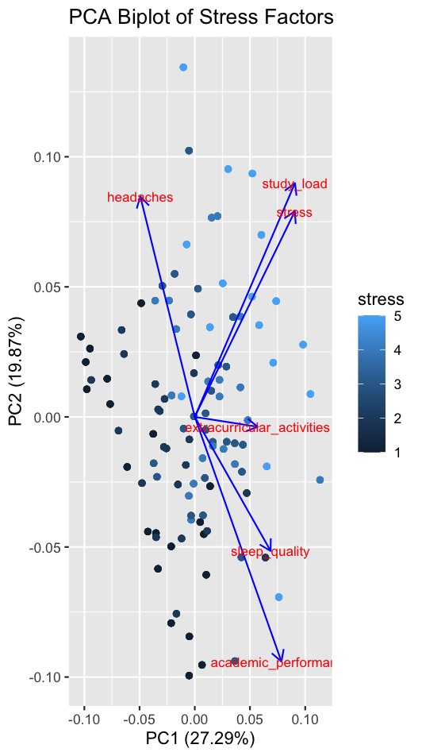
Figure 3.1

Unfortunately, dataset 1’s k-means clustering was not as successful. We first could tell from the elbow plot (Figure 3.2) that k = 3 clusters is optimal, however the subsequent silhouette score (Figure 3.3) of 0.17 suggests that clusters exist but overlap significantly, as seen in Figure 3.4. Silhouette scores below approximately 0.25 typically indicate weak clustering structure, which is expected in subjective psychological survey data. Between the PCA space and Figure 3.5 which shows us the centers of each cluster, we are able to interpret what these clusters actually represent. Cluster 1 contains students with lower stress, lower study load, and a moderate lifestyle behavior. Cluster 2 is more moderate stress levels with balanced characteristics and, lastly, cluster 3 contains students with high stress, a heavy study load, and more headaches. The strong overlap suggests that student stress profiles vary continuously rather than form strong boundaries.
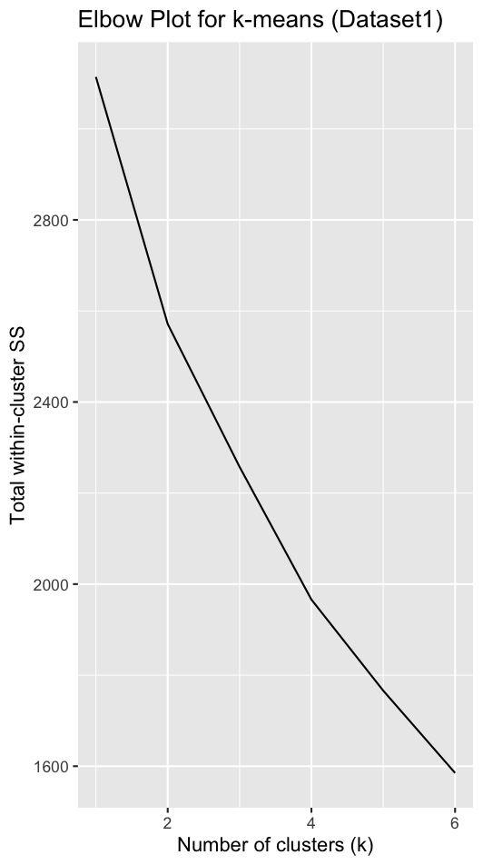
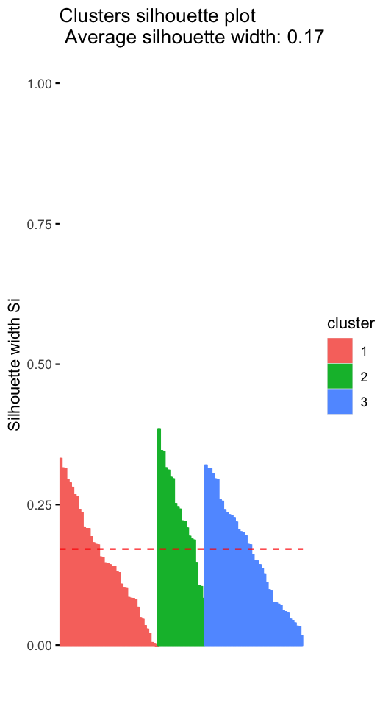
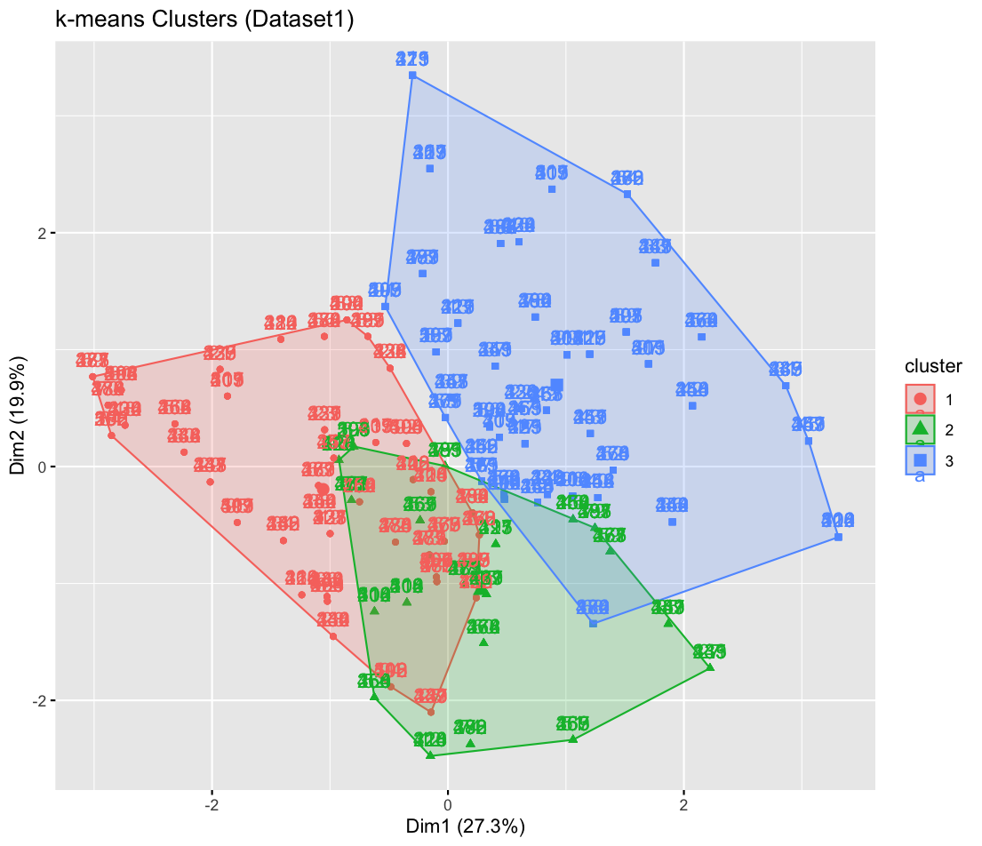
Figure 3.2 (left), Figure 3.3 (middle), and Figure 3.4 (right)

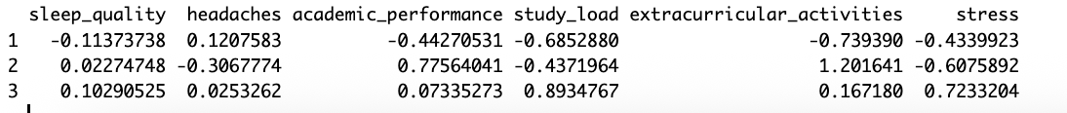
Figure 3.5

The k-means clustering conducted for dataset 2 unfortunately did not perform much better, with a silhouette score of 0.19 for 3 clusters. Figures 3.6, 3.7, 3.8, and 3.9 show the same steps as performed for dataset 1. We can see that cluster 1 contains students with high screen time, higher stress, and lower happiness. Cluster 2 represents low screen time, lower stress, and higher happiness, and cluster 3 has students with moderate screen time and moderate well-being. Figure 3.8 suggests there is definitely less overlap between clusters, but the silhouette score being so low again shows weak separation.

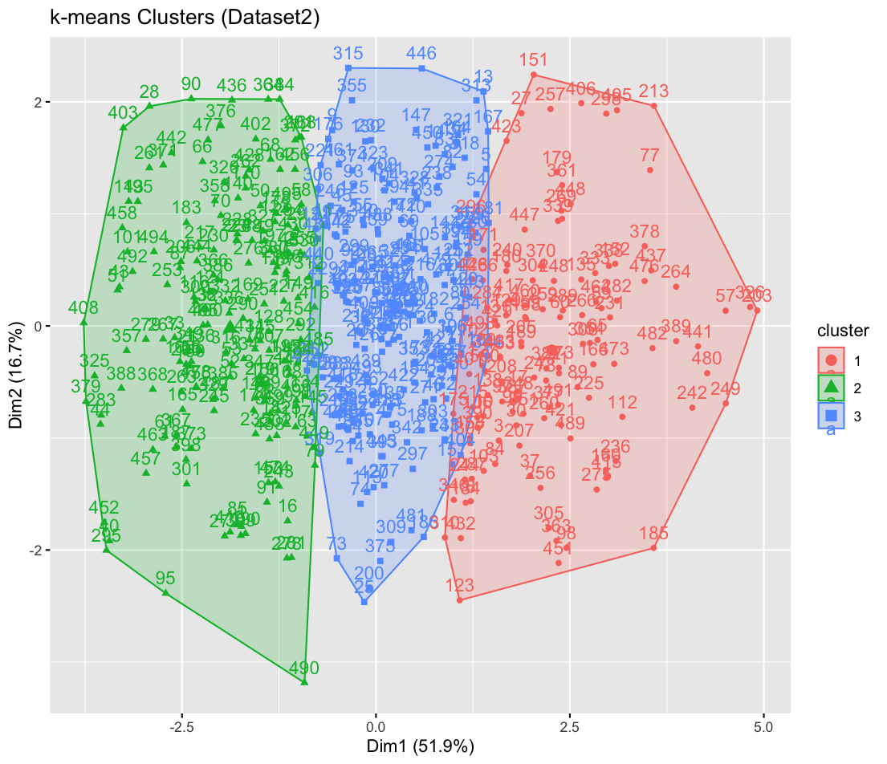
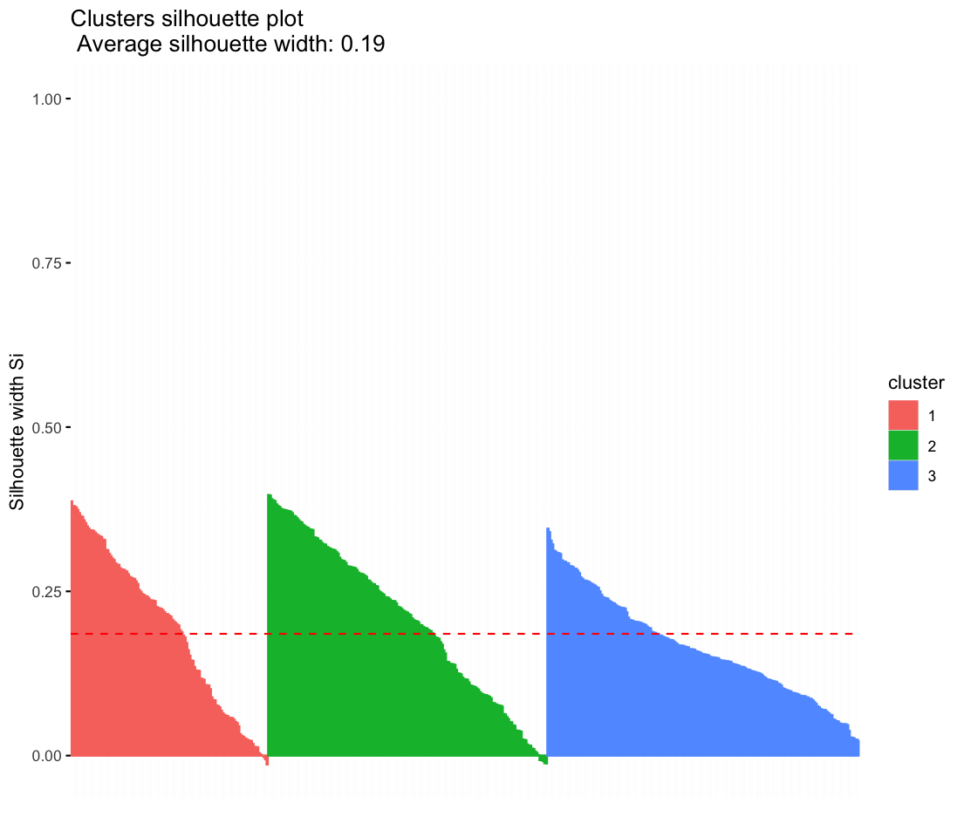
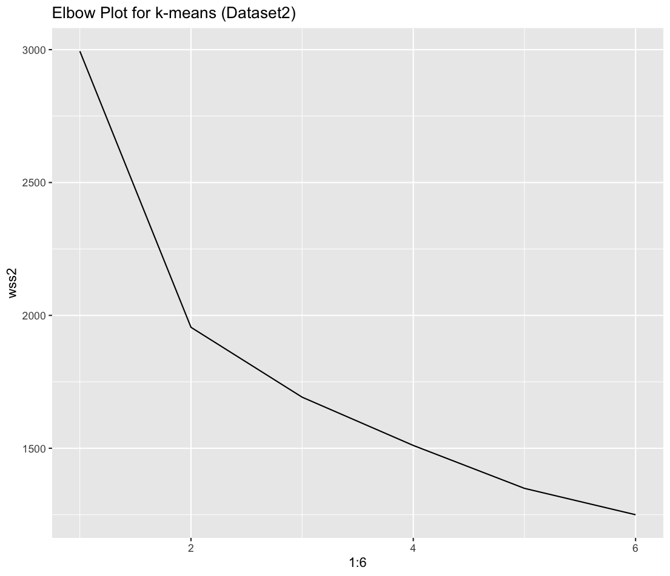
Figure 3.6 (left), Figure 3.7 (middle), and Figure 3.8 (right)

Figure 3.9

Although the clusters did not perform as well as I hoped, I am still able to draw some key exploratory conclusions. First, stress and happiness behaviors cluster into low, moderate, and high profiles. Digital behaviors such as screen time show stronger grouping structure than academic behaviors, supporting the initial thought that increased technology has played a key role in increased stress. Lastly, PCA and clustering consistently display multi-factor relationships rather than single-variable dominance, also supporting that there are a multitude of factors, rather than just screen time, that influence student stress.
Section 4: Model Development and Application
Next it is important to apply what I have learned from the preliminary analysis to develop a series of models to further classify groups and predict stress and happiness. Dataset 1’s regression uses sleep quality, headaches, academic performance, study load, and extracurricular activities to predict stress. As seen in the model’s results (Figure 4.1), study load and sleep quality are significant predictions of increased stress whereas academic performance and headaches have weaker effects. However, headaches are not statistically significant, so it is hard to concretely finalize its relationship with stress. Study load, on the other hand, is statistically significant at p < 0.05. Thus, it is a significant driver of stress. The findings from the residual graph and Q-Q plot (Figure 4.2) suggest that the model captures some structure but may miss nonlinear relationships. Additional nonlinear modeling could help improve fit and the model's predictive performance.

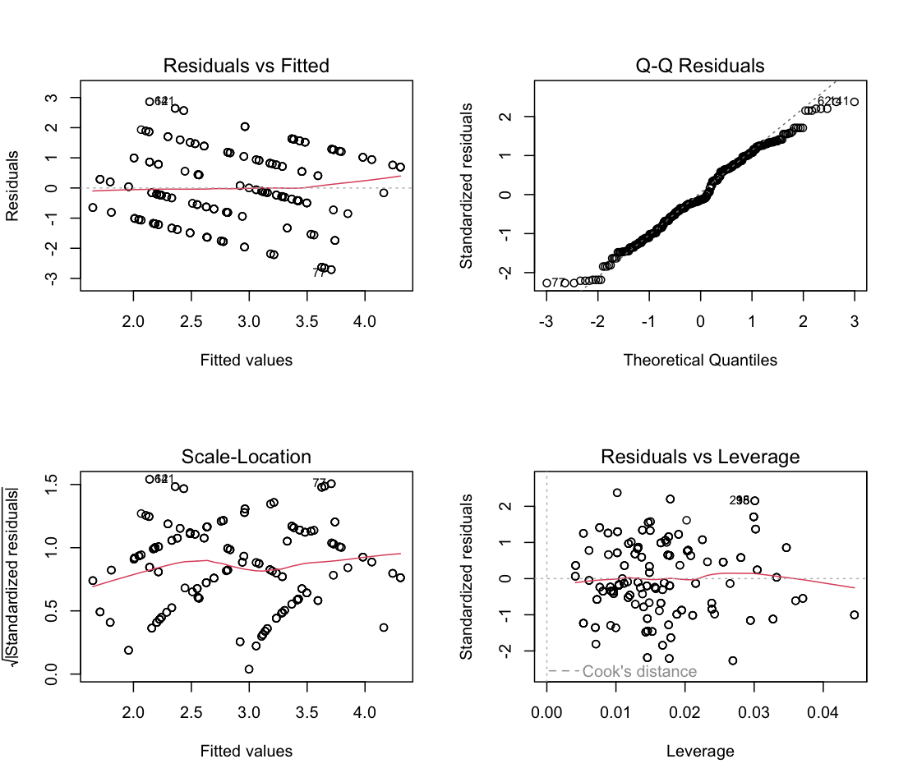
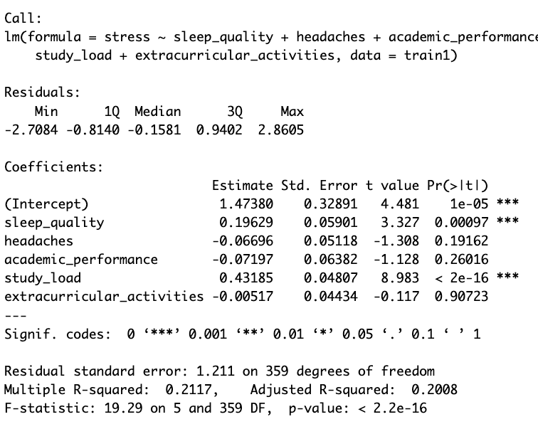
Figure 4.1 (left) and Figure 4.2 (right)

Dataset 2 followed a similar multiple linear regression model using screen time, sleep quality, stress, days off social media, and exercise to predict happiness. The model’s results (Figure 4.3) suggested that screen time and stress are negative predictors of happiness, stress being statistically significant at p < 0.05. On the other hand, exercise and sleep quality (statistically significant at p < 0.05) are positive predictors. These relationships were definitely expected, but confirmation is valuable. The diagnostic plots (Figure 4.4) show good normality, some heteroscedasticity, and an overall stable model. Because residuals displayed curvature and heteroscedasticity, the linear model assumptions are only partially met. This does not invalidate the model but suggests results should be interpreted directionally rather than as precise predictive estimates.
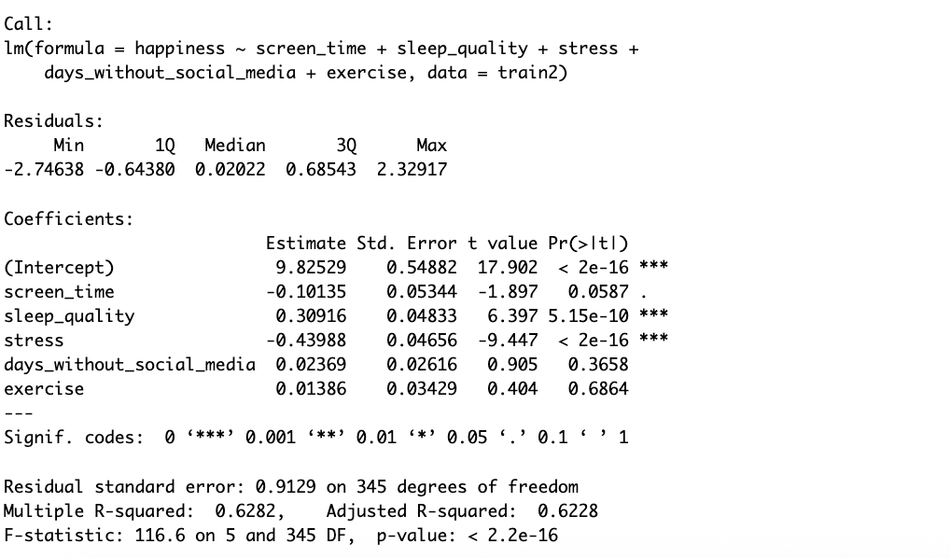
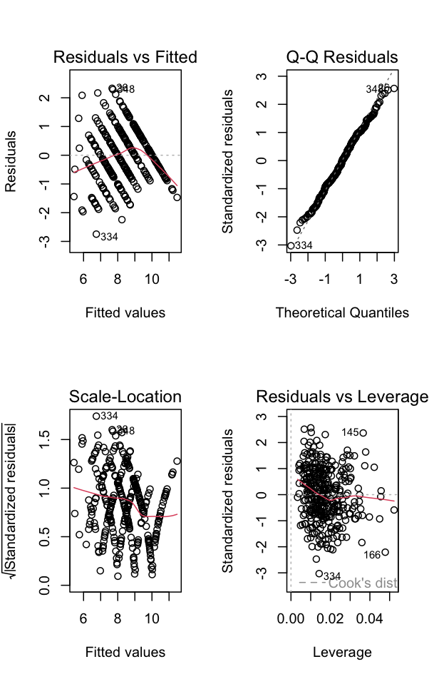
Figure 4.3 (left) and Figure 4.4 (right)

\

kNN classification for dataset 1 was the next model performed, attempting to predict high vs. low stress. First, stress values were converted into a binary class label using the median split, creating two new groups: high stress and low stress. Five standardized predictors were used for classification: sleep quality, headaches, academic performance, study load, and extracurricular activities. kNN is the most appropriate choice because the stress-labeled observations exist in a low-dimensional feature space and the boundaries between high and low stress may be nonlinear. Next the dataset was split into training and testing splits (70/30) to allow proper model evaluation and the kNN algorithm was then used to classify students as high or low stress. The model was tested for multiple values of k (1, 3, 5, 7, …, 13) to evaluate how model complexity affects accuracy. The accuracy vs. k plot (Figure 4.5) was generated to visualize performance across different k values.

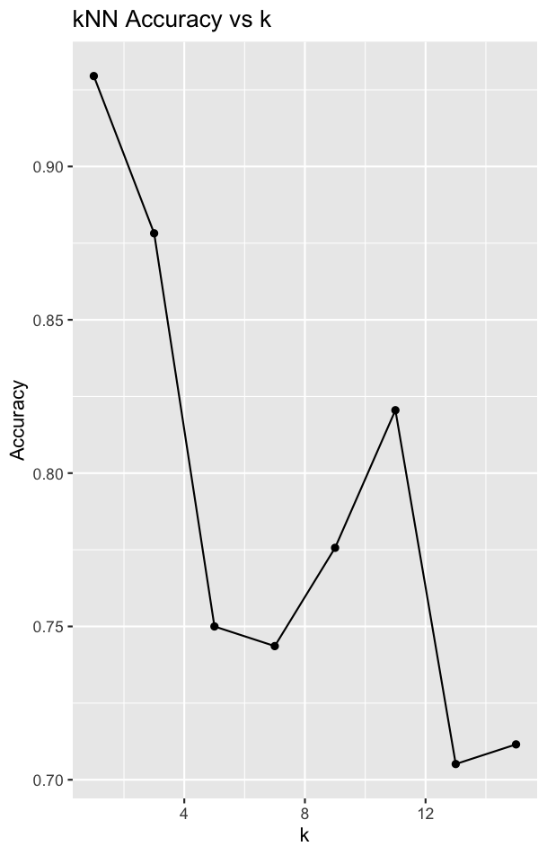
Figure 4.5

Highest accuracy at k = 1 (approximately 92%) suggests that stress level is strongly determined by a student’s immediate neighbors in feature space, meaning students with similar habits tend to have similar stress levels. Accuracy subsequently decreases as k increases, demonstrating that small k values effectively capture local structure and larger k values introduce excessive smoothing, reducing discriminatory power and accuracy. This performance pattern suggests that students with similar features like study load and headache levels tend to have similar stress levels. Further, the strong performance at low k values indicates that dataset 1 contains distinct behavioral patterns that separate low and high stress cases.
Next, we can revisit the patterns found in dataset 1’s PCA and both datasets’ k-means clustering. First, along with the PCA biplot (Figure 3.1), a scree plot (Figure 4.6) and a scatterplot of PC1 vs. PC2 (Figure 4.7) was also used. Figure 4.7 shows considerable continuous spread with no strong cluster boundaries, similar to the silhouette analysis. This further analysis of the PCA further revealed the multidimensional nature of student stress, as no single component dominated the structure, helping to interpret clustering and regression results by revealing relationships between features.

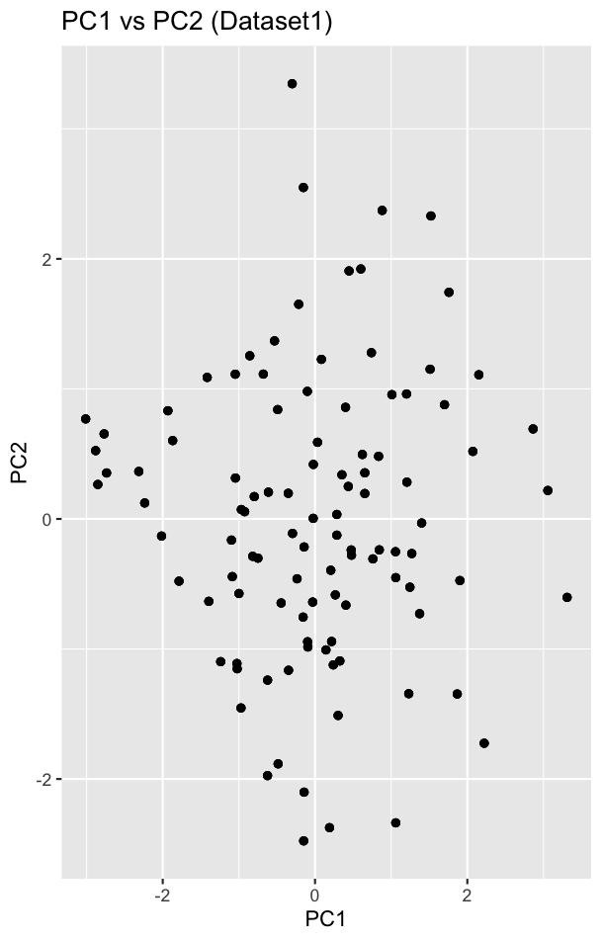
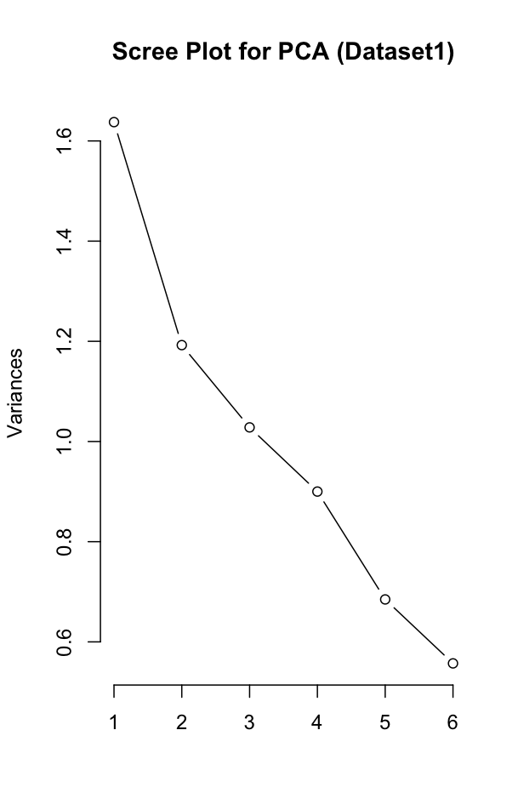
Figure 4.6 (left) and Figure 4.7 (right)

Further analysis of the k-means clustering used for both dataset 1 and dataset 2 reveals a multitude of things about both groups. As aforementioned, dataset 1’s clusters (Figure 3.5) can be grouped into clusters of low, moderate, and high stress. The overlap between clusters also suggests that student stress exists on a continuum rather than in sharply defined categories, consistent with self-reported Likert-scale psychological data.
Dataset 2’s k-means clustering performed in a similar manner, a little stronger separation than dataset 1, but still modest. There were, once again, three clusters: high screen time and low happiness, low screen time and high happiness, and moderate levels of both. These results confirm that digital behavior meaningfully separates students into different mental-health profiles.
Section 5: Conclusions and Discussion
From the series of models and analysis, we are able to come up with some major findings. First off, study load and headaches are major drivers of student stress. It would be interesting to see if there is any reverse causality in these relationships, as it is easy to imagine stress can lead to headaches and even increased study load. Next, screen time strongly predicts lower happiness, confirming increased technology has a negative effect on mental health. Sleep quality influences both models, albeit weaker than expected. Lastly, students fairly naturally fall into low, moderate, and high wellness categories, suggesting the right predictor variables were used.
From our models, it is clear linear regression reveals directional effects but is limited by nonlinearity, begging the question: how would data with continuous variables differ? Next, kNN classification effectively identifies high-stress individuals, further suggesting the correct predictor variables were used. Lastly, clustering effectively provides behavioral profiles that can definitely be juxtaposed and identified.
There were, as there are with any study, some limitations that came with my work. As aforementioned, self-reported data introduces bias and noise and likert scales limit numerical precision. Although hard to do, finding this data in a way other than a survey would prove beneficial. Next, datasets lack time-series structure meaning we cannot infer causality, increasing the probability as the aforementioned reverse causality. Lastly, there were no demographic controls, causing confounding variables like socioeconomic background to not even be included.
The results of this study introduces many possibilities for future work. For example, nonlinear models such as random forests and gradient boosting could have been used to better capture complex patterns. Next, more longitudinal data can be collected to explore causal pathways among individuals. Mental-health validated scales for depression and anxiety could be introduced to reduce survey bias and further standardize the data. Lastly, the results of the analysis could lead to early-warning prediction tools to be introduced in education systems, benefitting those who struggle with student stress and mental health altogether.

Works Cited
A. “Academic Stress Factors among Students.” Kaggle, 18 Oct. 2025, www.kaggle.com/datasets/ayeshasiddiqa123/academic-stress-factors-among-students.
Rajak, Prince. “Mental Health & Social Media Balance Dataset.” Kaggle, 15 Oct. 2025, www.kaggle.com/datasets/prince7489/mental-health-and-social-media-balance-dataset.

kyks. “The Rising Tide of Student Stress: Understanding Our Pressure.” Medium, 10 Apr. 2024, medium.com/@kyksss/the-rising-tide-of-student-stress-understanding-our-pressure-f6415f66a629.

